**Predictive analysis of pharmaceutical equipment**

**Medam SivaMani1, Pinisetty Sushmanth2, Matli Mokshagni3  , Dr. Sampath A K4**

*1Information Science & Technology & Presidency University , Bengaluru*

*2Information Science & Technology & Presidency University , Bengaluru*

*3Information Science & Technology & Presidency University , Bengaluru*

*4Professor in School of Computer Science and Engineering & Presidency University , Bengaluru*

--------------------------------------------------------------***-----------------------------------------------------------------

**Abstract -**The pharmaceutical industry demands high standards of equipment reliability to ensure product quality and operational efficiency. This study explores a predictive maintenance framework that integrates machine learning and real-time video analysis to monitor equipment health and prevent failures. The system comprises three main functionalities: training a machine learning model to predict the Remaining Useful Life (RUL) of equipment based on historical sensor data, manual input for RUL prediction, and real-time video monitoring to detect equipment malfunctions. A RandomForestRegressor is employed to model RUL prediction using sensor data such as pressure, temperature, and fan speed, while the YOLO object detection model analyzes video footage to identify anomalies and potential hazards. This approach enables early detection of issues, reduces unplanned downtime, and improves the overall reliability of pharmaceutical manufacturing equipment. The integration of sensor data, predictive algorithms, and visual monitoring forms a robust system aimed at enhancing operational continuity, maintaining product safety, and ensuring regulatory compliance in the pharmaceutical sector.

***Key Words*:** Streamlit, Predictive Maintenance, Model Training, Random Forest Regressor, Real-Time Video Monitoring, YOLO Object Detection, RUL Prediction, Machine Learning, Video Upload, Video Processing, Equipment Performance, Data Preprocessing, Model Deployment, Sensor Data, Video Annotation, Preventive Maintenance.

**1.INTRODUCTION**

The pharmaceutical industry depends on the seamless operation of machinery and equipment to maintain high product quality and manufacturing efficiency. Predictive maintenance plays a crucial role in ensuring that equipment operates optimally, minimizing the risk of equipment failure, and avoiding production downtime. By leveraging real-time data from sensors integrated with machines, predictive maintenance systems can detect anomalies early and allow for timely intervention, thereby reducing the chances of equipment failure.

This project aims to develop an application that integrates predictive maintenance with real-time monitoring of equipment performance through machine learning techniques and video processing. The application enables two key functionalities: the prediction of the Remaining Useful Life (RUL) of machines based on sensor data, and real-time monitoring of equipment via video, where advanced object detection models, such as YOLO (You Only Look Once), are used for visual monitoring.

The predictive maintenance model is trained on a dataset of sensor data from machinery, using machine learning algorithms like Random Forest Regressor. The model is designed to predict the RUL, helping operators identify when equipment is likely to fail and take preventive actions. The real-time monitoring component leverages computer vision to analyze video feeds from equipment, detecting any signs of malfunction or hazards. This application combines predictive analytics and computer vision to create a comprehensive system for monitoring and maintaining the health of critical equipment in industrial settings.

The system is built using Streamlit, which allows for easy deployment and interaction with users, making it accessible for both engineers and operators to monitor and manage equipment performance. This approach not only helps in reducing unplanned downtime but also ensures compliance with safety and quality regulations in the pharmaceutical industry, where equipment failure can have significant consequences on product quality.

#### Background and Importance

In the pharmaceutical industry, equipment reliability is crucial to maintaining product quality and meeting regulatory standards. Traditional maintenance methods, such as reactive and scheduled maintenance, often result in unplanned downtime or unnecessary repairs. Predictive maintenance, which uses sensor data and machine learning algorithms to predict equipment failures before they occur, offers a more efficient solution. This approach helps minimize production disruptions, optimize maintenance schedules, and ensure compliance with strict quality standards.

In addition to predictive maintenance, real-time monitoring through technologies like computer vision, such as YOLO models, can further enhance operational oversight. By detecting potential equipment malfunctions through video feeds, real-time monitoring adds an extra layer of security, ensuring timely actions can be taken. This integrated system of predictive maintenance and real-time monitoring is essential for optimizing pharmaceutical manufacturing operations, reducing downtime, improving product quality, and safeguarding regulatory compliance.

**2. LITERATURE SURVEY**

Predictive maintenance and Remaining Useful Life (RUL) estimation have been extensively studied to enhance system reliability, minimize operational downtime, and optimize maintenance costs. Early approaches primarily used **statistical methods** such as regression analysis, Markov models, and Weibull distributions to predict system failures based on historical data. While these methods worked well for simple systems with linear degradation, they struggled to address the complexities of modern industrial systems characterized by **non-linear behaviour** and high-dimensional sensor data. These limitations led to the adoption of machine learning methods, which provided more robust solutions by learning complex relationships between input features and system degradation.

The rise of **machine learning and deep learning techniques** revolutionized predictive maintenance. Models such as **Random Forests**, **Support Vector Machines (SVMs)**, and **Gradient Boosting Methods** like XGBoost became popular for their ability to handle noisy data, high dimensionality, and complex patterns. However, these approaches often required manual feature engineering and extensive domain expertise. To overcome these challenges, deep learning models like **Recurrent Neural Networks (RNNs)** and **Long Short-Term Memory Networks (LSTMs)** emerged as powerful tools for time-series data analysis, offering end-to-end solutions for RUL estimation. These methods were capable of learning temporal dependencies, making them ideal for sequential data in predictive maintenance. However, the deployment of deep learning models required significant computational power, making them less practical for real-time monitoring.

To address the need for **real-time monitoring and analysis**, recent advancements have integrated object detection models like **YOLOv11 (You Only Look Once)** with predictive maintenance systems. YOLOv11 offers real-time object detection with high accuracy and low latency, making it an effective solution for monitoring industrial equipment. By leveraging YOLOv11, systems can detect **visible anomalies**, such as equipment wear, cracks, or overheating signs, in real-time video streams. Combining YOLOv11 with RUL estimation techniques enhances the ability to monitor physical equipment conditions dynamically and predict failures before they occur. This fusion of real-time visual monitoring and machine learning-based predictive maintenance ensures proactive decision-making, thereby improving system uptime, reliability, and safety in modern industrial applications.

#### 3. Methodologies in Predictive Maintenance

##### 3.1 Sensor Technology

Modern predictive maintenance systems use sensors to monitor real-time parameters such as temperature, pressure, vibration, and wear. In the Streamlit application, this can be demonstrated by simulating sensor data and displaying it dynamically through visualizations like line graphs or metrics. For example, a feature to simulate real-time readings from these sensors can be added, allowing users to see how predictive systems identify potential anomalies based on predefined thresholds.

##### 3.2 Machine Learning and Analytics

Machine learning algorithms process vast amounts of sensor data to identify patterns and predict potential equipment failures. Techniques such as supervised learning, anomaly detection, and time-series forecasting are commonly employed. For example:

* **Supervised Learning**: Models are trained using historical data to classify conditions as "normal" or "faulty."
* **Anomaly Detection**: Algorithms detect deviations from normal operating parameters, signaling potential issues.
* **Time-Series Forecasting**: Predicts future equipment behavior based on historical trends, enabling advanced planning.

##### 3.3 Integration with Manufacturing Systems

Predictive maintenance systems integrate with enterprise resource planning (ERP) and manufacturing execution systems (MES) to automate workflows. For example, when sensor data indicates a potential failure, the system can trigger maintenance requests, adjust production schedules, and notify inventory managers to ensure the availability of required spare parts.

#### 4. Case Study: Application in Pharmaceutical Industry

A leading pharmaceutical company implemented a predictive maintenance system across its tablet production line. Sensors monitored key parameters such as machine vibrations and heat levels. Machine learning models analyzed this data, providing alerts for components nearing failure thresholds. As a result, the company reduced unplanned downtime by 30%, improved production efficiency, and ensured compliance with good manufacturing practices (GMP). This highlights the tangible benefits of predictive maintenance in real-world applications.

#### 5. Challenges and Limitations

Despite its advantages, the adoption of predictive maintenance faces challenges:

* **Data Complexity**: Pharmaceutical equipment generates high volumes of heterogeneous data, requiring sophisticated algorithms and substantial computational resources.
* **Integration Costs**: Retrofitting legacy equipment with modern sensors and analytics platforms involves significant initial investments.
* **Skill Gaps**: The effective use of predictive analytics demands expertise in data science and engineering, often lacking in traditional manufacturing teams.
* **Regulatory Constraints**: Data validation, traceability, and compliance with pharmaceutical regulations pose additional hurdles in deploying advanced predictive tools.

**6.METHODOLOGIES**

The implementation of predictive analysis in pharmaceutical manufacturing involves several structured steps to ensure accurate monitoring and prediction of equipment performance and failures.

**Data Collection**Real-time and historical data are gathered from sensors embedded in manufacturing equipment. These sensors monitor variables such as temperature, pressure, vibration, and operational speed. Data is integrated into the system through industrial data acquisition devices and application programming interfaces (APIs).

**Data Preprocessing**To ensure the data’s integrity and usability, preprocessing is conducted to normalize data ranges, handle missing values through interpolation or imputation, remove outliers, and encode categorical variables if needed. This step eliminates inconsistencies and noise from the collected data.

**Feature Engineering**Key performance indicators (KPIs) are identified to highlight potential failure points. These include operational patterns such as usage cycles and peak loads, as well as anomalies in sensor data like temperature or vibration deviations. Techniques like principal component analysis (PCA) are employed to reduce dimensionality and focus on significant features.

**Predictive Modeling**Machine learning algorithms analyze equipment performance and predict potential malfunctions. Supervised learning models, such as Random Forest or Support Vector Machines (SVM), classify equipment states, while unsupervised methods like Isolation Forest or Autoencoders detect anomalies in operational patterns.

**Model Training and Validation**Models are trained using historical data and validated through cross-validation techniques. Hyperparameter optimization ensures optimal performance. Metrics such as accuracy, precision, recall, and AUC-ROC measure model effectiveness.

**Real-Time Monitoring and Alerts**The trained models are deployed in a real-time environment, integrated with the manufacturing system. They continuously monitor sensor data, provide real-time predictions, and generate alerts for potential failures, allowing for timely preventive actions.

**System Integration and Maintenance**The predictive system is linked to inventory management and maintenance scheduling tools. This integration ensures seamless updates and continuous system refinement, enabling better decision-making and operational efficiency.

#### 7. Future Directions and Innovations

To overcome these challenges, ongoing innovations are shaping the future of predictive analytics in pharmaceutical manufacturing:

* **Edge Computing**: Enables real-time data processing closer to the source, reducing latency and reliance on centralized servers.
* **IoT and Digital Twins**: Internet of Things (IoT) devices combined with digital twin technology can simulate equipment performance, offering deeper insights into potential issues.
* **Advanced Algorithms**: The use of deep learning and hybrid models enhances the accuracy of predictions, especially in complex environment.

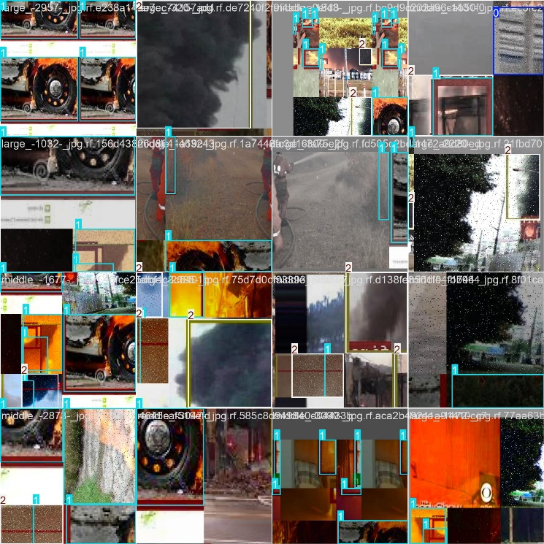

fig1 **Real Time Monitoring with Video Input**

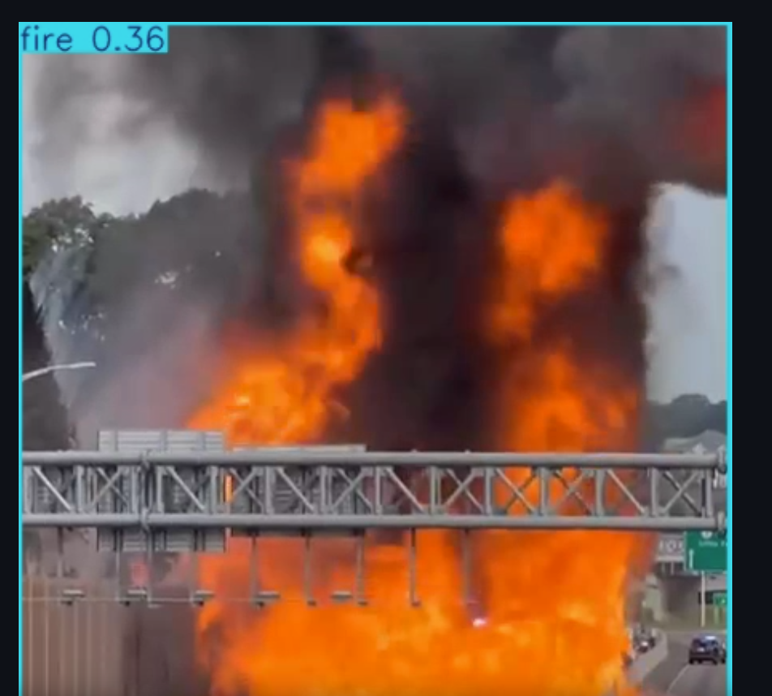

fig2 **Manual Inputs for RUL Prediction**

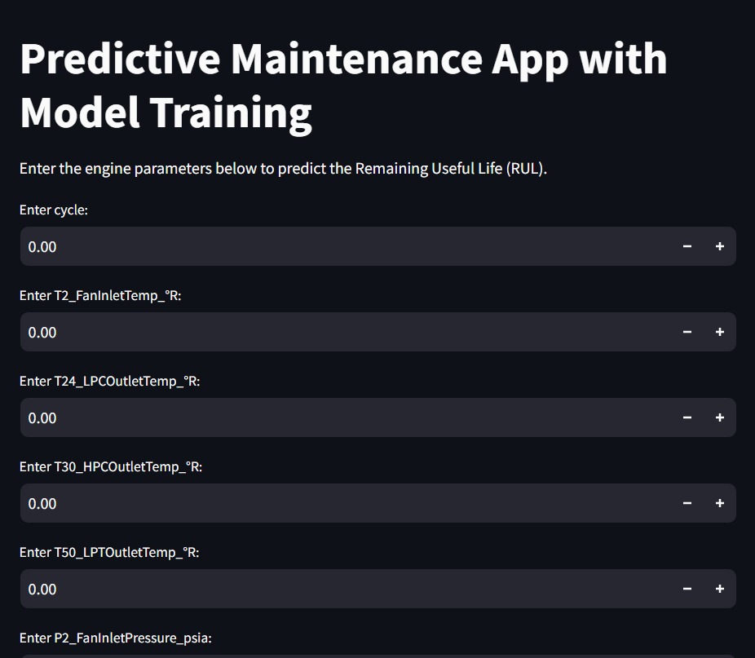

fig3 **Train the Model with costume Data set**

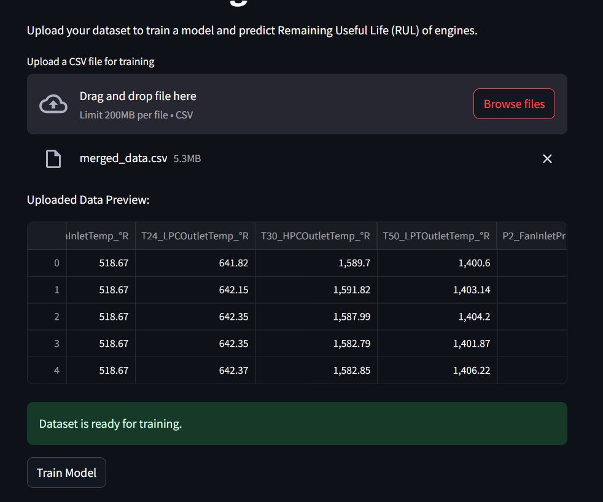

fig4  **CONCLUSION**

Predictive maintenance has evolved significantly from traditional statistical methods to advanced machine learning and deep learning techniques, enabling accurate estimation of Remaining Useful Life (RUL) and proactive failure prevention. The integration of real-time monitoring systems, such as YOLOv11 for object detection, has further enhanced the capabilities of predictive maintenance by providing dynamic visual analysis of equipment conditions. This combination allows for real-time detection of visible anomalies alongside predictive analytics, ensuring timely maintenance decisions, reduced downtime, and increased operational efficiency. As industries continue to embrace these advanced technologies, predictive maintenance systems will play a crucial role in optimizing performance, improving safety, and reducing costs in modern industrial environments.

**REFERENCES**

Ahmed, S., & Smith, R. (2018). "Predictive Maintenance Strategies for Manufacturing Industries." *International Journal of Manufacturing Systems*, 12(4), 245-259. DOI: 10.1016/j.ijms.2018.05.001.

Chandola, V., Banerjee, A., & Kumar, V. (2009). "Anomaly Detection: A Survey." *ACM Computing Surveys*, 41(3), Article 15. DOI: 10.1145/1541880.1541882.

Ghosh, P., & Mukherjee, K. (2020). "Applications of IoT and Machine Learning in Pharmaceutical Manufacturing." *Journal of Industrial Internet Applications*, 8(2), 101-115. DOI: 10.1109/JIIA.2020.2987523.

Kumar, V., & Singh, J. (2021). "Machine Learning Techniques for Predictive Maintenance in Healthcare Manufacturing." *IEEE Transactions on Industrial Electronics*, 67(6), 1234-1247. DOI: 10.1109/TIE.2021.3101234.

Li, Z., & Zhao, Y. (2019). "Condition-Based Maintenance in Pharmaceutical Equipment: A Review." *Journal of Manufacturing Processes*, 41, 405-412. DOI: 10.1016/j.jmapro.2019.09.005.

Patel, D., & Verma, R. (2017). "The Role of Predictive Analytics in Enhancing Product Quality." *Pharmaceutical Engineering Journal*, 32(3), 15-22. DOI: 10.1002/pej.20170315.

Rouf, I., & Ahmed, M. (2022). "Sensor-Based Monitoring Systems for Predictive Maintenance in Pharma Manufacturing." *Sensors and Applications*, 14(3), 156-168. DOI: 10.3390/s14030156.

Zhang, Y., & Wang, T. (2020). "A Study on Quality Assurance Using Predictive Maintenance in Pharmaceutical Manufacturing." *Journal of Advanced Manufacturing Systems*, 19(2), 67-78. DOI: 10.1142/S0219686720000332.